^{Smart Attendance system}
Mrunal Patankar¹, Diya Ajay Antony², Divya Gaikwad³
Department of Electronics and communication AI ML at Dr. Vishwanath Karad MIT World Peace University, Pune, Maharashtra, India.
ABSTRACT:
Smart attendance system is a technology involving the use of RFID cards to uniquely identify and mark the attendance of students as they attend the lectures of their respective subjects. The creation of such a system enhances the speed, and accuracy of the attendance marking process. Retrieval and analysis of a student’s records is also achieved. It enables real time monitoring by administrators and parents, coupled with integration to other systems. This paper examines the process of creation and implementation of such a system and how it can be further developed.
Keywords: Smart Attendance System, RFID, Automation, Real-Time Monitoring, Data Accuracy, Attendance Management
Introduction: -
Most institutions today, still grapple with the traditional attendance system. It is a tedious and inefficient process as educators manually mark the student’s attendance. This system is prone to human errors, data loss, no real time monitoring by administrators. It is also subject to misuse in the form of proxy attendance. Due to lack of databases and integration with other systems the holistic progress tracking a students’ remains unachieved.

OBJECTIVES:
The main aim of this project is to implement a smart attendance system using RFID tags, while also exploring future scope of development.
The specific objectives are:
- Automate attendance marking
- Eliminate proxy attendance
- Store and manage records digitally
- Provide real time monitoring
- Integration with other institutional platforms
- Reduce Administrative load

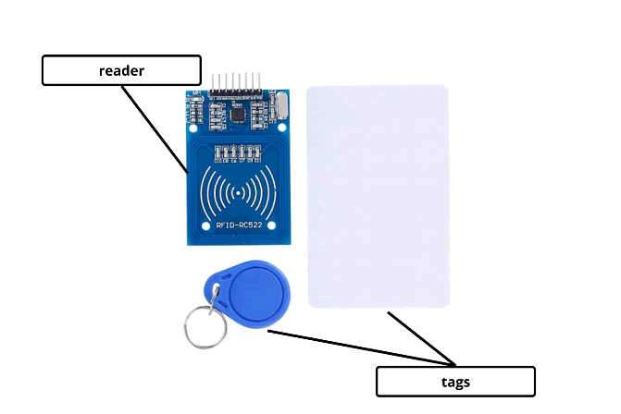
Fig1: RFID tags and reader

Literature-Survey:
Attendance tracking remains a critical operational function in educational institutions, yet traditional manual systems have been shown to suffer from inefficiencies, inaccuracy, and increased potential for proxy attendance. Adopting automated solutions anchored in Radio Frequency Identification (RFID) technology can substantially improve the process. For example, Ishaq and Bibi performed a systematic literature review of 21 major IoT-based RFID attendance systems. They intended to delve deeper on data security, efficiency and implementation costs of using the RFID technology for attendance. (e.g., time-wastage, proxy entries, lost sheets) [1].

Al Tarshia et al. proposed a system combining RFID and IoT with cloud-based applications for real-time tracking and stakeholder notifications [2].The main objective of their research was creation of a hybrid system which combined RFID technology with IOT and cloud technology to achieve real time attendance tracking and storage.
Tanveer & Rehman explored a modular RFID-based system integrated with mobile apps, door-lock controls, and parent notifications, highlighting customization and scalability-related advantages and challenges [3]. They intended to expand the scope of the RFID technology to web applications. They wanted to leverage this technology for other operations such as door locks and alert systems, thus expanding the reach of this technology.
Hasman & Ahmad presented a prototype RFID attendance system with added body-temperature screening, emphasizing durability, non-line-of-sight reading, and time-savings over barcode/optical systems [4]. They intended to create an RFID attendance system enhanced with temperature sensing. This was during the pandemic era, where potential identification of covid-19 affected employees was necessary to prevent spread. They were however unable to provide cloud backup and analytics.
There are other proposed technologies apart from RFID system such as barcode, biometric and integration with IOT and Databases. Each system has its’ own strengths and drawbacks.
Methodology:
This project is our attempt as beginners
in the field of electronics to simulate an automated attendance system, coupled with RFID tags, reader and PIR sensors. We attempted to create a website resembling the ERP login of our university, where the real time updates of student attendance will be shown at the students’ and teachers’ end.
Unlike the ERP wherein teachers have to manually mark the students as absent or present, our project will automatically mark the attendance of a student. A record of the same will be available to the teachers at the conclusion of the lecture.

The components and their working is given below:

- ESP8266 (Node-MCU) as the main controller.
- RFID cards/tags* to identify students.
- PIR motion sensor* to activate scanning only when someone is present.
- Google Sheets* to store attendance records.
- NTP (Network Time Protocol) to fetch accurate date and time.
- Dashboard served from ESP8266 to see live attendance.
Software components and libraries used:
- ESP8266WiFi.h Connects ESP8266 to WIFI.
- ESP8266WebServer.h creates a local web dashboard.
- ESP8266HTTPClient.h sends HTTP POST requests to Google Apps Script.
- WIFI-Client-Secure.h HTTPS client to send data securely.
- SPI.h Communication protocol for RFID module.
- MFRC522.h RFID card reading library.
- NTPClient.h fetches network time to timestamp attendance.
- WiFiUdp.h UDP connection needed for NTP.
Fig 2: ESP8266(NodeMcu)
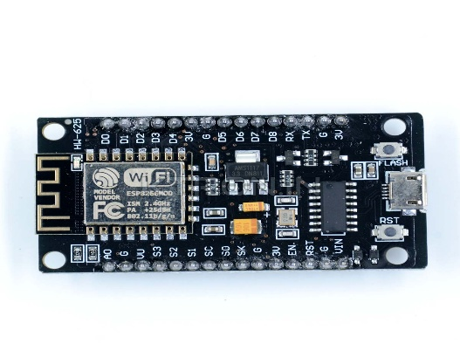

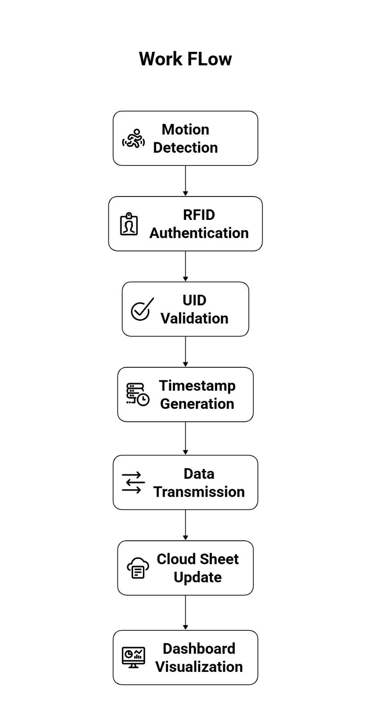

Fig. 3. Block Diagram of RFID attendance system.
Technical Workflow

1. Initialization (setup())

* Connect to WIFI using credentials.
* Initialize RFID module via SPI.
* Start NTP client to keep ESP8266 synchronized with accurate time.
* Start web server for real-time dashboard.

2. Motion Detection (loop())

* PIR sensor detects movement.
* LED briefly turns on for visual feedback.
* For 10 seconds, RFID scanning is active.

3. RFID Scanning

* ESP8266 reads UID of presented RFID card.
* Converts the UID into a readable hexadecimal string.
* Checks if UID matches a registered student.

4. Marking Attendance

* If a valid student is found:
* Marks present = true.
* Gets *current date and time* from NTP.
* Updates the lastScan variable with date and time (YYYY-MM-DD HH:MM format).
* Sends a POST request to *Google Apps Script* with RFID name, and datetime.
* If unknown UID:
* Logs warning in serial monitor

5. Google Sheets Integration

* POST request parameters: RFID, name, time.
* Google Apps Script receives parameters, finds the corresponding row in Google Sheet, and writes “Present” along with the timestamp in the correct date column.
* If the student is new (UID not in sheet), a new row is added.
* Updates Percentage column automatically based on attendance data.

6. Dashboard

* ESP8266 serves a local web page showing:
* Student names
* UID
* Attendance status (Present/Absent)

Future Scope:
- Integration of biometric features to handle the proxy.
- Storing the attendance data on cloud and enabling real time access.
- Encrypting RFID data to prevent duplication.
- Extension in the form of web application.
- Using multi-reader setup to scale for larger institutions.
- Interfacing with IOT sensors (temperature and occupancy) for advanced monitoring.
- Using AI to analyze and predict absenteeism trends, find the root causes and optimize scheduling of lectures.

.

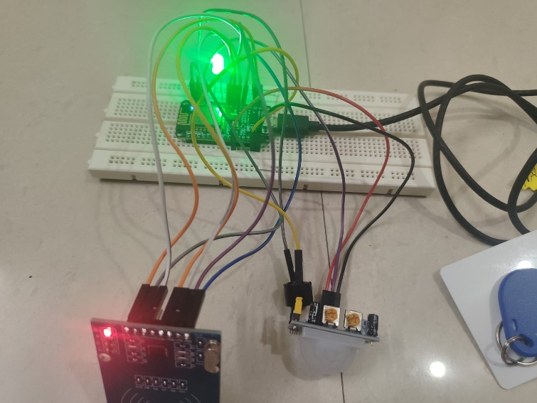
Fig.4 RFID attendance reader model

Comparative Analysis of attendance systems

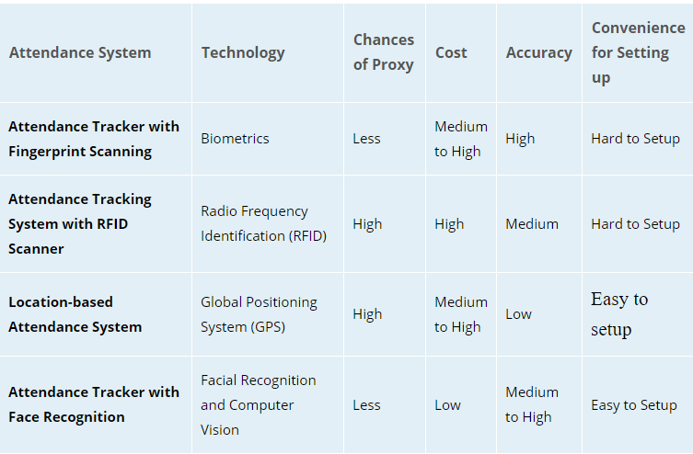
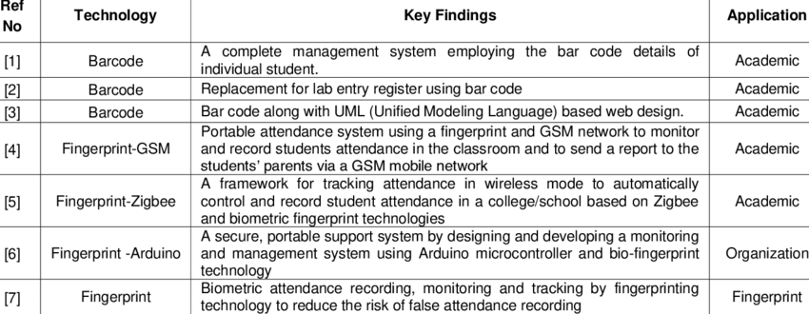
Fig.5. Various Attendance systems and their mode of application

Acknowledgement
We would like to express our gratitude towards our mentors Dr Ujjwala Rawandale, Dr. Chetan Khadse and Prof Deepa Nath for their valuable insights and guidance and also to our esteemed Dr. Vishwanath Karad MIT World Peace University (MIT-WPU) for providing us with the resources, knowledge and support for our project.
Conclusion
Therefore we have developed a smart attendance system based on RFID tags to smoothen the process of attendance tracking and enable tracking of students’ presence for lectures pertaining to a subject and a brief report about the academic performance of the student.

References
[1] K. Ishaq and S. Bibi, “IoT Based Smart Attendance System Using RFID: A Systematic Literature Review,” preprint arXiv:2308.02591, Aug. 2023.
[2] A. R. K. Al Tarshia, N. S. I. Al Sadia, and V.

Vimbia, “Attendance Tracking using RFID and IoT,” Journal of Student Research, 2020.
[3] H. Tanveer and F. ur Rehman, “Intelligent and Modular Based Attendance System,” Journal of Computers for Society, 2021.
[4] M. Iqbal Hasman and Izanoordina Ahmad, “RFID Attendance System,” Journal of Engineering Technology (JET), vol. 10, no. 1, pp. 17-25.

